Ladybirds Day Nursery: Activity Plan
Activity Name: |  |  |  |  |  | Target age group:
Small World Tuff Tray |  |  |  |  |  | All Ages
Activity Description:
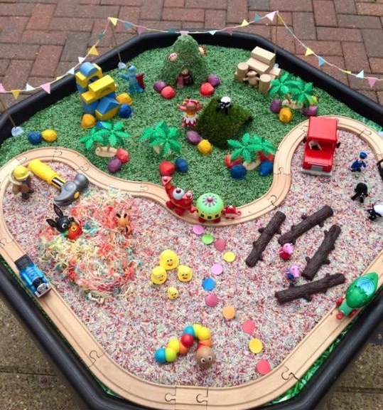
A wide range of resources can be used to encourage small world play in a tuff tray. This activity encourages exploration of different roles in play. It can also be great for some schemas as they can move and transport toys and materials into different parts of the tray. Lots of opportunity for counting out vehicles and people as well as positional language. A good way to make small world more personal is to add pictures of the children to bricks so they can play themselves and ther peers.
Resources Needed:
Corn flakes
Rice Crispies
Oats
Mud
Sand
Rice
Fake Grass
Cars
Animals
Small world people
Bricks to make buildings
Sticks
Leaves
Tape or chalk for numbered parking spaces
Pictures of children printed and laminated
EYFS: |  |  |  |  |  | COEL:
PSED |  | CL |  | PD |  | Playing and Exploring: Engagement  Finding out and exploring  Playing with what they know  Being willing to ‘have a go’
MR  SCSA  MFB |  | LA  U  S |  | MH  HSC
L | M |  | UW |  | EAD | Active Learning: Motivation  Being involved and concentrating  Keeping Trying  Enjoying achieving what they set out to do
R  W | N  SSM |  | PC  TW  T |  | EUMM  BI
Creating and thinking critically: Thinking
Having their own Ideas
Making Links
Choosing ways to do things
Key Vocabulary / Open ended questions
How can we……?
How did……?
What else could we add to make it different?
Is there another way we could do that?
What would happen if….?
What do you think about….?
What would you do…….?
Which part did you like best?

Under
On Top
Behind
Above
Beside
Around
Numbers

