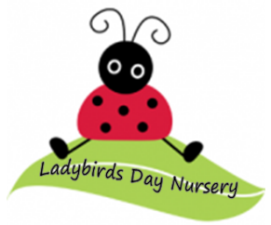
What’s New?

Photos: We have concept photography coming into the setting on Thursday 23rd May to take professional photos of the children. Should you wish for your child to have their photo taken and it isn’t their usual day, feel free to bring them in from 8:30am to have theirs done.

Theme for May -
Our theme for the month of April is Dinosaurs. Look out on Tapestry for all the fun activities our staff have organised.

Funding for School leaver this year- The last day of funding for children that are going to school in September is Friday 30th August.

Graduation 2024- Our graduation for this year will be on Saturday 20th July 12pm- 2pm. You will get more details closer to them time.

Ladybirds Day Nursery
May 2024

Things to remember:

Summer-
As Summer is approaching and the weather is becoming pleasantly warmer, please could we ask that all children start to bring labelled sun hats, sun cream and water bottles with them so we can enjoy our outdoor area as much as possible.

Session times- Please can we ensure we are sticking to the hours booked for your child. The nursery opens at 8am any children booked in before this time pay to be here from 7:30. If you would like to book in for a 7:30 start please let the office know.

Sickness- If your child is going to be absent from Nursery, please can you call or email to let us know.

Term Dates-

Summer Term Part 1:
15th April – 24th May.
Summer Half Term:
27th May –31st May.
Summer Term Part 2:
3rd June – 12th July.
Summer Holidays-
15th July- 2nd September

